Meta Description:
The meta description is a brief summary of a web page that informs the user and search engines about the pages. It is designed to attract users in brief time.
https://drive.google.com/drive/folders/1ybcXYFhJxuNXqEklQPPrjGjse4E1spAN
Interlinking:
https://threeanglemarketing.com/what-is-seo-an-intro-to-search-engine-optimization/
Meta Description

Comprehensive Guide to Meta Descriptions: Importance, Best Practices, and Tools
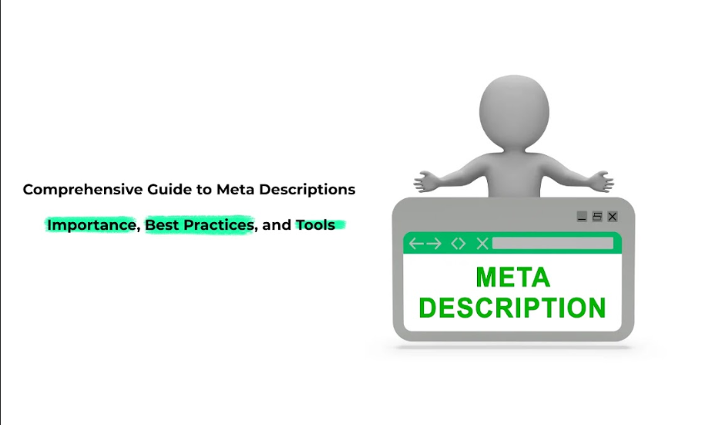
Nowadays it is critically significant to pay much attention to writing proper meta tags, specifically meta descriptions. These pieces of text are very crucial when it comes to SEO. Because meta description ensure that the users spend time on your site. It is therefore very crucial to have a well-optimized meta description to have a good CTR or else your website may go unnoticed.
In this guide, we will discuss what meta descriptions are, how to create them, how they should be used, and how they can be optimized.

What are Meta Descriptions?
Meta tag description is a description of the content of a page that is inserted in the html code of a particular website. It possesses an average of 150 to 160 characters, which gives the user an idea of the content they are to be shown when they click from the SERP.

Why Meta Descriptions Matter for Search Engine Visibility and User Engagement
Meta descriptions are very important and useful in the promotion of traffic and increasing the use of websites among users. While meta descriptions have no direct correlation to Google’s ranking factors, they have a great influence over click-through rates (CTR). The important meta tag is the Meta description that, unlike the Meta title, can make visitors click on the link to your site instead of your competitor, to increase site visibility and traffic. Besides, meta descriptions are useful for search engines, as they allow understanding the context of the specified content, which makes indexing more effective.

Key Characteristics of an Effective Meta Description:
The meta description should be brief, give key information, and drive the client’s attention to the website. Here are some key characteristics:
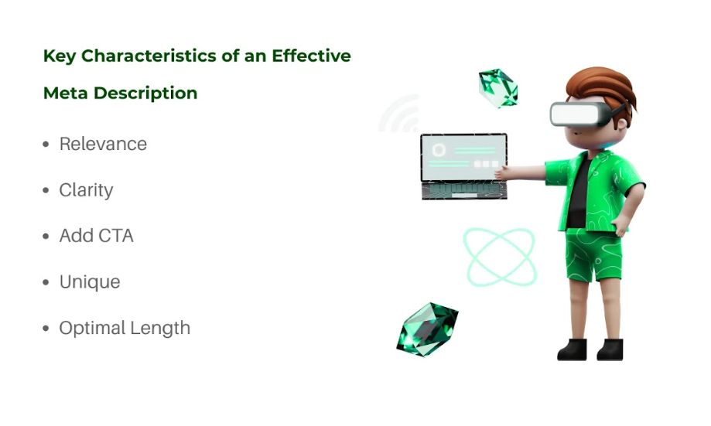
- Relevance: With reference to the topic, it should consist of keywords that are within that topic.
- Clarity: Use clear and straightforward language.
- Add CTA: It is important to include a CTA in this meta description because it makes it very compelling to click on.
- Unique: Avoid duplication across pages.
- Optimal Length: The text can only allow up to 150-160 characters to avoid the possibility of truncation.

The Role of Meta Descriptions in SEO
Meta tags are one of the HTML elements that allow search engines to identify the subject matter of the displayed page. Although it is not actually a factor that figures into Google’s ranking equation, they nevertheless have been shown to have a great impact on the way users behave. Given that meta description directly influences the CTR it is a very important factor of SEO effectiveness.
With higher CTRs, your website is likely to attain better rankings over time to reflect the search engine’s algorithms that see it as an indication of relevance and quality. Also, due to their relevance to the content, meta descriptions assist search engines in eliminating unwanted or insignificant material, the significance of which cannot be overemphasized as far as your SEO plan is concerned.
- CTR: A well-written Meta tag must improve the click-through rate meaning that search engines will consider the content valuable and relevant.
- Target keywords: Placed in the meta description may help your focus to fall on the elements of the web page that match the appropriate keywords for the users’ queries.
- User Needs: Meta descriptions ensure that only those users click on the link who are really interested in your product and services. Additionally, meta descriptions also ensure attracted traffic has a high-quality conversion rate.

How to Craft Effective Meta Descriptions?
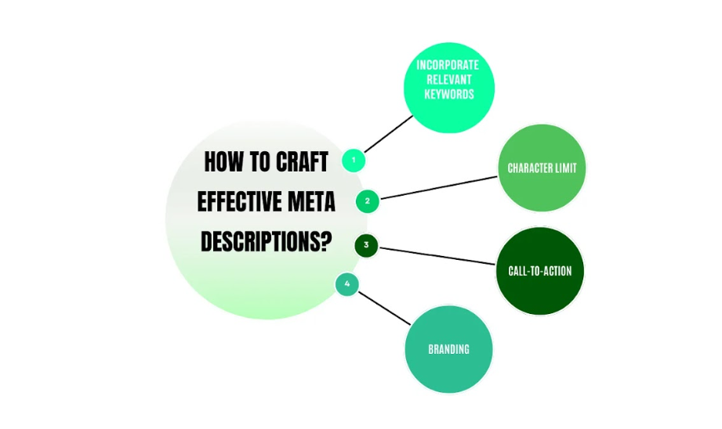

Incorporate Relevant Keywords:
It is worth including keywords that relate to your content in the meta description to increase its proficiency. Although it is not good practice to use a high density of keywords, their proper placement may lead to an increase in CTR and will be useful for search engines to determine the context of the page.

Character Limit:
The meta description does not need to be written at all, an optimum meta description should range between 150 to 160 characters. This helps to make all the content of the description viewable especially if it has been shortened in SERPs. What matters most is to have properly constructed messages which at the same time are short yet informative when limited to this character count.

Call-to-Action:
A call-to-action (CTA) position in the meta description can improve CTR to a great extent. Pointing words like ‘Learn more’, ‘Get started’, or ‘Read now’ make the user click on the company website link.

Branding:
Meta description Respond Using Brand Names. This is usually a good practice because it will help in improving the level of recognition and trust especially when the company puts its brand name into description. However, it should not dominate the message or the keywords of the content of the page or post.

How Google Displays Meta Descriptions?
As a rule, the snippet shown in the search results is created using the meta description that is given in the HTML code for the site. However, if the meta description is not available or if the search engine finds it unsuitable it will automatically take a description from the page. This means that you must write a proper meta description to have the ability to manage how a particular page appears to the viewers of the search engine.

Factors Influencing Google's Use of Meta Descriptions
- Duration: To maintain the long descriptions’ searchability, it is advisable not to go beyond the recommended character limit in Google.
- Quality: Google may ignore descriptions that are composed of clickbait-like or misleading phrases and words.
- Relevance: The type of descriptions which are closer to the content of the page will be used.

Optimal Meta Description Length for Maximum Impact
So, when it comes to the Meta descriptions, then the longer the better is valid. Usually, meta descriptions have a limited length and most of the search engines such as Google cut them short on desktop at around 155-160 characters and on mobile at around 120-130 characters. It is also important to understand the constraints based on the above information to make the meta description fully visible in the SERP.

Recommended Character Count (Desktop vs. Mobile)
  - Desktop: Aim for 150-160 characters. It lets you give a full message.
  - Mobile: Limit to 120-130 characters. As mobile phones are rapidly becoming popular, it is important to provide a functional mobile version to prevent the message from being cut halfway.

Ideal Length to Avoid Truncation
Due to this issue of truncation, it is prudent to keep between 155 characters for the description to fit on the desktop view and 120 characters for the mobile view. This guarantees the possibility that your message is viewed fully which increases the chances of click-through rates.

Variations across Different Search Engines
Google is the outstanding search engine right now, other search engines such as Bing or Yahoo might provide more or fewer snippets. To fit all the characteristics into a meta description while not risking being penalized, it is advisable to use not more than 155-160 characters for the desktop and 120-130 for mobile.

Balancing Brevity and Information Density
In general, meta-descriptions recall the need to convey a lot of information in as few words as possible. Your task is to express the main idea of what is offered on your page in brief. This involves coming up with appropriate words in the content they develop so that they can be as explicit as possible when they have to be without relaying unnecessary information.

Avoiding Keyword Stuffing While Maintaining Clarity:
In using the keywords, it is crucial to avoid using excessive keywords within the meta description because it will make potential visitors avoid the site. However, do not overcrowd the text by pressing for the idea of keyword density but it is recommended to stringently follow the natural flow of the language by incorporating the most significant keywords in the text.

How to Write an Effective SEO Meta Description (Best Practices)?
Writing a good meta description requires the following aspects to be incorporated in the tag. Such practices ensure to have meta descriptions that are good at attracting people to click in addition to being valuable to the targeted audience.

Key Elements of a High-Performing Meta-Description
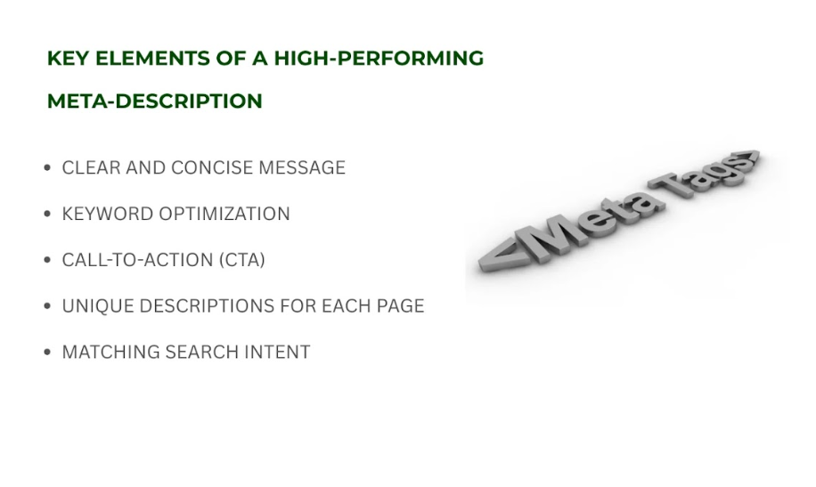

Clear and Concise Message:
Your Meta Title should be a clear and concise description of the content on your page. The structure should be simple and appear logical at first sight.

Keyword Optimization:
It allows you to incorporate keywords you have underlined as most important in your website naturally into your meta description. This is done to make the search engines realize the relevance of the specific page to certain keywords.

Call-to-Action (CTA):
Make the CTA persuasive to compel the viewers to click on the link. Examples of such phrases as “Learn more”, “Get started”, and “Discover how” will help the users to make a call to action.

Unique Descriptions for Each Page:
Make sure not to repeat meta descriptions for multiple web pages, because this will have a bad impact on the SEO. This contributes to SEO but also guarantees that every website page’s content is unique and properly described.

Matching Search Intent:
Your meta description should mirror the users’ search intent. If you are coming up with a list of pages that address a certain issue, make sure your description captures this.

Common Mistakes to Avoid:

Keyword density:
This may result in the use of twisted and irrelevant words within a sentence. Focus on readability and relevance.

Writing Vague or Generic Descriptions:
When writers get lazy, they are likely to write vague descriptions, which are unpleasing to the audience. Be specific on what you are offering on the page and emphasize the unique selling point that is on the page.

Failure to Consider Mobile Users:
Google has enhanced browsing through mobile devices and website meta descriptions should not be cut off when displayed on mobile devices.

How to Add a Meta Description to Your Website?

Step-by-Step Implementation Guide

For CMS Platforms (WordPress, Shopify, Wix, etc.)

- WordPress: Utilize SEO plugins like Yoast SEO or Rank Math. These plugins allow the user to work with meta descriptions more closely and add them to their posts almost immediately within the editor. All you need to do is go to the ‘SEO’ tab located below the editor and input the description.
- Shopify: Navigate to your online store’s settings, then to the SEO section. Here you can customize the meta description for every page of your SiteBarner Template. Shopify also supports applications such as Yoast SEO for extra capability.
- Wix: Go to the Wix Editor, to the tab ‘Settings’, and then click on ‘SEO (Google).’ Here you can plan and implement meta tags that are related to certain pages only.

Use Built-in SEO Plugins
- Yoast SEO: As one of the simplest plugins, Yoast SEO assists in the proper organization of meta descriptions. The plugin offers immediate feedback and recommendations.
- Rank Math: It is another SEO plugin available that’s slightly more feature-rich than Yoast with added features such as auto-generated Meta tags from your blog content.

Manual Entry in Page Settings
For those who do not want to use extensions, which is a more suitable method if you are not a developer or using a content management system, you may manually set the meta descriptions within the settings of your CMS or the website builder you use.

For HTML Websites:
- Editing the `<meta>` Tag: Depending on the content management system that you are using, you need to open the Code Editor and find the `<head>` of your HTML code. You should add or modify the part, called `<meta name=” description” content=” Your meta description here” >`.
- Testing and Validation: It is essential to check how your meta descriptions may look in SERPs after making changes, including using Google Search Console. This helps in the proper display of descriptions you want to give and also gives an understanding of how they are performing.

Testing and Validation

Check How Descriptions Appear in SERPs
To see how meta descriptions look in the search, use tools such as Google’s ‘Fetch as Google’ in the Search Console tools. It enables you to check whether or not your descriptions are the way they are and are not reduced in size.

Use Google Search Console for Insights
It is essential to use Google Search Console because it can provide information regarding how your meta descriptions are ranking. It is crucial to track CTR and modify it in a bid to optimize engagement.

Top Meta Description Optimization Tools

Free and Paid Tools for Crafting & Auditing Meta Descriptions

SEO Plugins:
- Yoast SEO: Provides multiple SEO features such as meta description.
- Rank Math: It offers all the functionalities of its free version with added automation features.

SERP Preview Tools
- Moz: It enables the user to see how the page is like to look like when it is being viewed by a search engine. This can help in optimizing the meta description.
- SEMrush: Provides a SERP checker feature where it allows you to compare your meta descriptions with that of your competitors.
- Ahrefs: Provides insights into how your meta descriptions compare with top-ranking pages.

Character Count Checkers
- SEO Meta in 1 Click: This is a Chrome extension that alerts the user on the length of their meta descriptions and even recommends improvements on the same.
- Portent’s SERP Preview: This is a tool where you can compose their meta tags and make some adjustments before it goes live.

How These Tools Help Improve Meta Descriptions?
It is very effective to use these tools as they serve the following functions to improve your meta descriptions:
- Meta Description: They enhance the management of meta descriptions and offer instant responses such as on-page optimization.
- SERP Preview Tools: This refers to tools that enable users to preview how their text descriptions are laid out in SERPS, to ensure they entice and are well presented.
- Character Limit Counters: Enable you to avoid exceeding the suggested number of characters so as not to have some of your stated message missing when shortened.

Best Practices to Implement Meta Description for Better SEO Performance
Given below are the best practices that can help you get the most out of your meta descriptions:
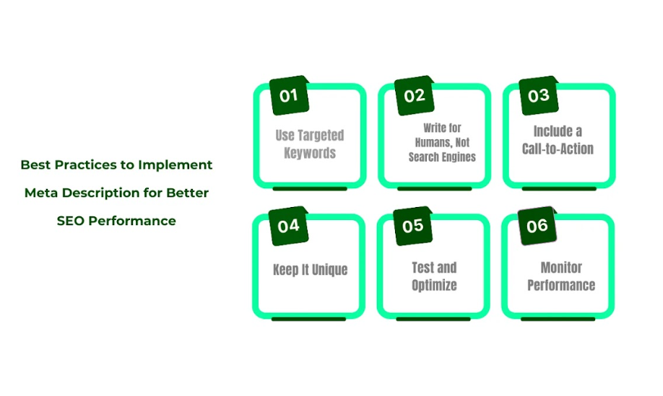

Use Targeted Keywords:
It is very necessary to include relevant keywords in the meta description as naturally as possible. This not only contributes to SEO but also to the identification of the textual description of the site in accordance with user search intent.

Write for Humans, Not Search Engines
You should not forget about keywords; their main aim is to present the message to potential visitors in the most effective and interesting way. This should be done with the idea of what will entice the person and get them to click the link.

Include a Call-to-Action
Use such calls to action as “Learn more” “Get started” or “Discover now” This can raise the rates of interaction and click-through rate.

Keep It Unique
It is very important that every page of your site has a meta description that is different from the one on the other pages as well as being optimized for keyword density. This does not cause repeated entries in a search result and makes it possible for every page to be indexed optimally.

Test and Optimize
It is advisable to frequently check and modify meta descriptions where necessary. Implementing two versions into the analysis can tell which specific descriptions are most effective in terms of CTR and interaction.

Monitor Performance
It is also important to track the performance of meta descriptions with the help of tools such as Google Search Console. Determine which descriptions are causing a higher click-through rate and implement your future AdWords campaigns accordingly.

Conclusion:

Meta descriptions are actually an essential part of the SEO strategy, which is not very popular among Website owners. When writing meta descriptions ensure that they are concise, well-written, and to the point, this way you will draw the right traffic to your site.

However, always bear in mind when it comes to meta descriptions, they should be SEO friendly while at the same time being friendly to the end users. It is always highly effective and powerful to maintain the descriptions as relevant, singular, and creative to effectively become your most essential weapon in digital marketing.

We at Three Angle Marketing are well aware of the SEO specifics and, therefore, will provide you with effective meta descriptions that will not only enhance your rank position but also attract more users. Contact us today to find out how we can help improve your website and accomplish your marketing objectives.

